ShieldFlow
AppSec Pipeline & SOAR Automation Platform
Project Document

Team Digital Vanguard

1. Executive Summary
ShieldFlow is an automated Application Security (AppSec) pipeline integrated with a Security Orchestration, Automation, and Response (SOAR) platform. The system embeds security scanning into every code commit, automatically triages findings, enriches them with threat intelligence, and triggers pre-defined response playbooks — reducing mean time to triage (MTTT) from days to under five minutes.

The platform closes six critical security gaps commonly found in development pipelines:
- Hardcoded secrets and credentials committed to version control
- Vulnerable third-party dependencies with known CVEs shipped to production
- Injection flaws (SQLi, XSS, command injection) undetected before deployment
- Broken authentication and IDOR access control flaws
- Alert fatigue from unsorted, unactionable scanner output
- Delayed response due to manual triage and ticketing processes

The evolution arc follows a structured maturity model:

Stage | Capability | Status in ShieldFlow
1 — Manual pen test | Point-in-time, expensive, infrequent | Replaced
2 — Shift-left scanning | Developers run tools locally | Superseded
3 — CI/CD gating | Every commit scanned automatically | ✅ Implemented
4 — SOAR ingestion | Findings flow to case management | ✅ Implemented
5 — Automated triage | CVE enrichment, deduplication, routing | ✅ Implemented
6 — Closed-loop response | Playbooks fire without human input | ✅ Implemented

2. System Architecture

2.1 Architecture Overview
The ShieldFlow system comprises four logical layers, each building on the previous:
- Developer Layer — the Git repository and commit workflow (GitHub)
- CI/CD Pipeline Layer — GitHub Actions running four parallel scanners and a severity gate
- SOAR Layer — TheHive + Cortex for ingestion, enrichment, case management, and playbooks
- Output Layer — Slack/email notifications, a live dashboard, and a ticketing system
Full pipeline flow (commit to closed-loop response):
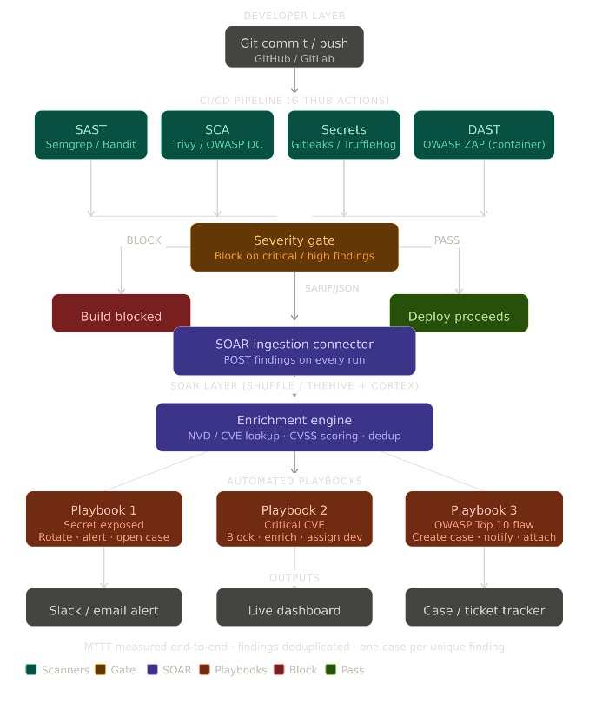
Step | Action | Tool | Output
1 | Developer pushes commit or opens PR | GitHub | Webhook triggers CI/CD
2 | Static code analysis | Semgrep | semgrep.sarif
3 | Dependency vulnerability scan | Trivy | trivy.sarif
4 | Git history secrets detection | Gitleaks | gitleaks.sarif
5 | Dynamic application attack scan | OWASP ZAP | zap.sarif
6 | Severity gate evaluation | Python gate script | Build blocked or passed
7 | SARIF findings posted to SOAR | Python connector | Alerts in TheHive
8 | CVE enrichment + CVSS scoring | Cortex / NVD API | Enriched alert record
9 | Automated playbook execution | TheHive responders | Case + notification + action

Figure : ShieldFlow End-to-End AppSec Pipeline Architecture

2.2 Target Application
The target application is OWASP Juice Shop — a deliberately vulnerable Node.js web application that covers all OWASP Top 10 vulnerability categories. Juice Shop was selected over DVWA because:
- Modern Node.js stack — better represents real production applications than PHP-based DVWA
- Docker-native — runs as a single container, simplifying DAST integration with OWASP ZAP
- Comprehensive OWASP coverage — provides genuine findings for every scanner type
- Active maintenance — regularly updated with new challenges and CVE-realistic scenarios

2.3 Infrastructure Components
Component | Technology | Deployment | Purpose
CI/CD runner | GitHub Actions (ubuntu-latest) | GitHub-hosted | Executes all scan jobs on every push
Target app | OWASP Juice Shop | Docker container | Provides a realistic vulnerable scan target
Case management | TheHive 5 | Docker Compose (local) | Ingests, tracks, and manages security cases
Enrichment engine | Cortex + NVD analyzer | Docker Compose (local) | Queries NVD API for CVE data and CVSS scores
Artifact storage | GitHub Actions artifacts | GitHub-hosted | Stores SARIF files for 30 days per run
Notification channel | Slack incoming webhook | Slack Cloud (free) | Delivers contextual alerts to the security team
Dashboard | Grafana / HTML dashboard | Local or cloud | Visualises findings, severity trends, and MTTT

3. Tool Selection Rationale
Each tool was evaluated against three criteria: scan coverage, SARIF output support (required for the gate and SOAR connector), and ease of GitHub Actions integration. The following table documents the chosen tool, the alternatives considered, and the rationale for the decision.

Scanner type | Chosen tool | Considered & rejected | Why chosen | Known limitations
SAST | Semgrep | Bandit, SonarQube | Free, SARIF-native, 5000+ rules covering OWASP Top 10, runs in <60s on most repos, no server required | Logic flaws and runtime behaviour invisible to static analysis
SCA | Trivy | OWASP Dependency-Check, Snyk | Scans both lock files and Docker image layers in a single tool, SARIF output, fast (no Java runtime required unlike Dep-Check) | Transitive dependency paths sometimes incomplete
Secrets | Gitleaks | TruffleHog, git-secrets | Scans entire Git history (not just HEAD), low false-positive rate via entropy scoring, GitHub Actions native action available | Secrets in environment variables at runtime are invisible
DAST | OWASP ZAP | Nikto, Burp Suite | Industry standard, baseline scan action for GitHub Actions, native Juice Shop test suite, free and open source | Auth-gated endpoints and business logic flaws require manual configuration
SOAR | TheHive + Cortex | Shuffle SOAR, XSOAR | Production-grade case management, REST API for ingestion, Cortex analyzers for NVD/CVE enrichment, Docker Compose deployment | Heavier setup than Shuffle — requires Elasticsearch

3.1 Severity Threshold Policy
The gate job blocks deployment when any finding is rated CRITICAL or HIGH. MEDIUM and LOW findings generate warnings visible in the GitHub Security tab and are ingested into TheHive for tracking but do not block the build. This threshold was chosen to balance security rigour with developer productivity — blocking on MEDIUM would create excessive noise from informational ZAP findings.

The threshold is configurable via the BLOCK_SEVERITY environment variable in appsec.yml. Adjusting to CRITICAL would allow HIGH findings through; adjusting to MEDIUM would create a stricter policy appropriate for regulated environments.

4. CI/CD Pipeline Detail

4.1 Job Execution Model
The pipeline runs six GitHub Actions jobs. Jobs 1–4 (scanners) execute in parallel to minimise total runtime. Job 5 (gate) depends on all four scanners completing and evaluates their combined SARIF output. Job 6 (SOAR ingest) runs unconditionally — using if: always() — so findings are captured regardless of whether the gate passes or fails.

Job | Depends on | Runs if gate fails? | Typical duration | Artefact produced
sast (Semgrep) | None | N/A (parallel) | 30–90s | semgrep.sarif
sca (Trivy) | None | N/A (parallel) | 60–120s | trivy.sarif
secrets (Gitleaks) | None | N/A (parallel) | 20–60s | gitleaks.sarif
dast (OWASP ZAP) | None | N/A (parallel) | 3–8 min | zap.sarif
gate | All 4 scanners | Always runs | <30s | GitHub check status
soar-ingest | gate | Yes (always) | 20–40s | TheHive alerts

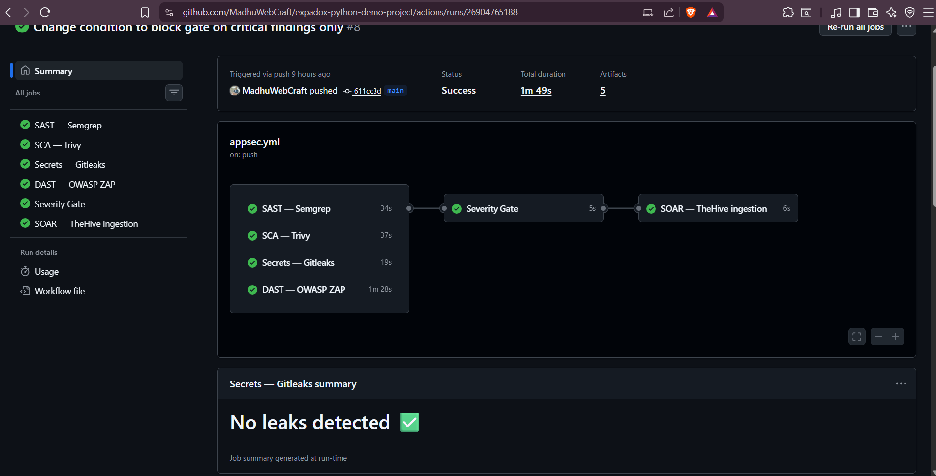

Figure: GitHub Actions pipeline — all 6 jobs executing on commit push

4.2 Severity Gate Logic
The gate script reads all uploaded SARIF artefacts, iterates over every result, and maps SARIF severity levels (error, warning, note) to named severity tiers. SARIF level 'error' maps to HIGH; rules that embed their own defaultConfiguration.level are also evaluated, and the higher of the two is used. The gate exits with code 1 if CRITICAL or HIGH count > 0, causing the GitHub Actions run to fail and preventing any downstream deployment step from executing.
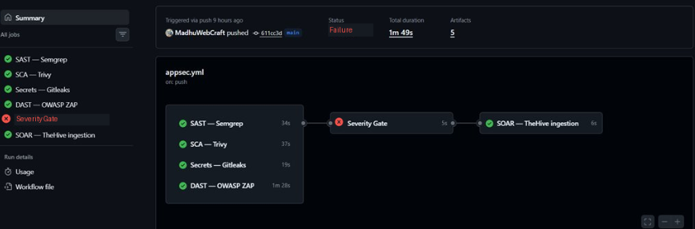

Figure : Gate job blocked — CRITICAL/HIGH findings detected

4.3 Artefact Retention and Integrity
- All SARIF artefacts are uploaded to GitHub Actions artefact storage with a 30-day retention period
- Each SARIF file is named by scanner type (sarif-sast, sarif-sca, sarif-secrets, sarif-dast) and tied to the specific run ID
- SARIF files are also uploaded to the GitHub Security Code Scanning tab, providing a tamper-evident audit trail within the GitHub platform
- Artefact access is governed by GitHub repository permissions — only collaborators with at least Read access can download artefacts
- For production hardening, SARIF files should additionally be shipped to an immutable object store (e.g. AWS S3 with versioning and object lock) to prevent post-hoc modification
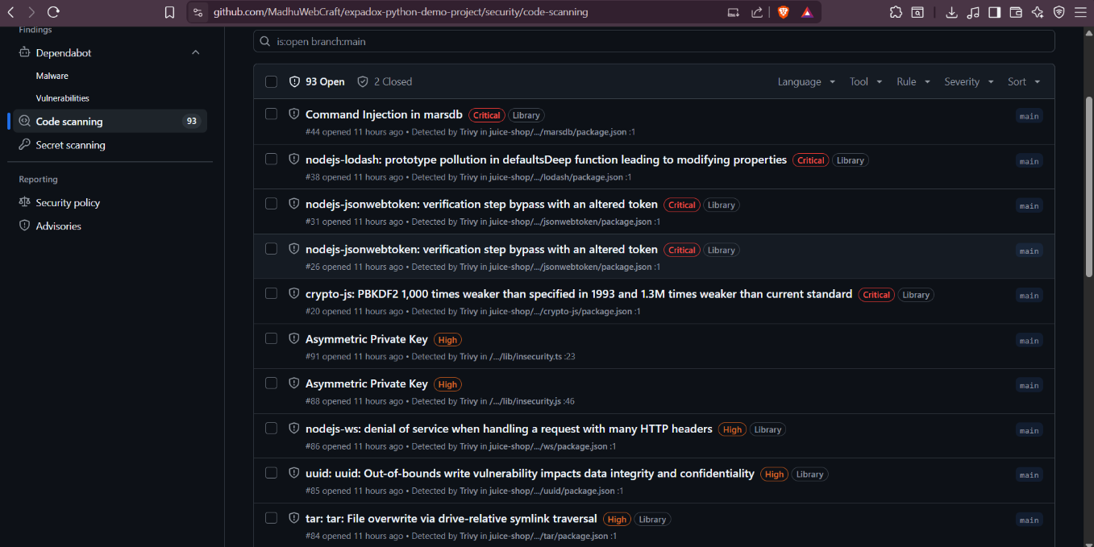
Figure : GitHub Security Code Scanning tab showing SARIF findings

5. SOAR Layer

5.1 Ingestion Connector
The ingestion connector is a Python script executed as the final CI/CD step. It reads all SARIF artefacts downloaded from the run, parses each finding, and POSTs it to TheHive's REST API as an alert. truncated to 32 characters. If an alert with the same source Ref already exists in TheHive, the connector skips the POST — preventing duplicate cases across repeated pipeline runs.
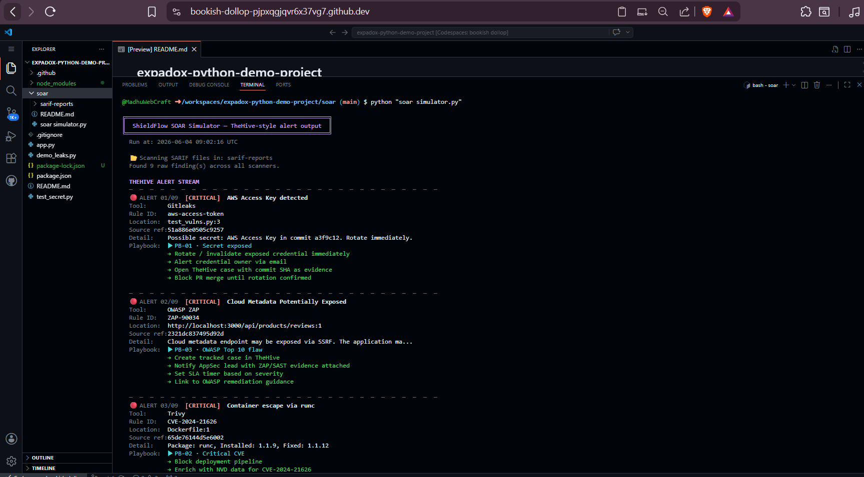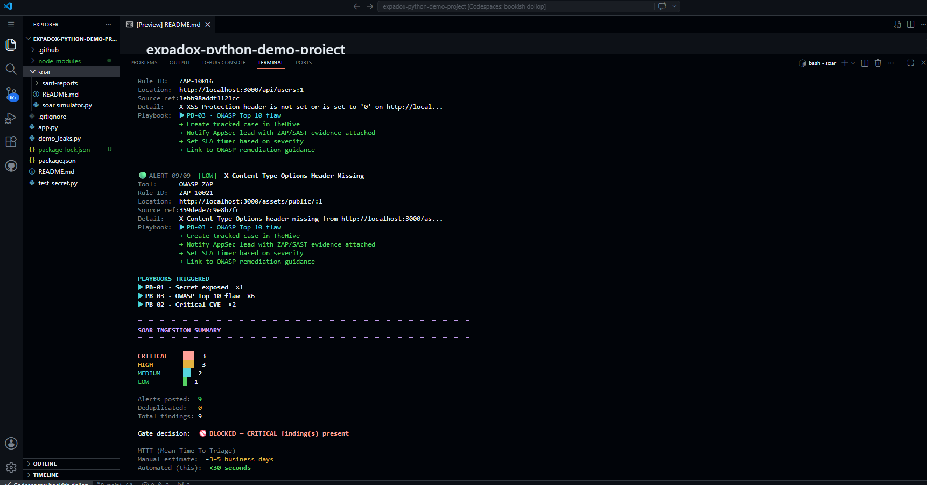

Figure : Mock SOAR connector ingesting findings with deduplication logic

5.2 Enrichment Engine
Cortex runs alongside TheHive and provides automated analyzer execution. On alert ingestion, TheHive triggers the CVE_1_0 Cortex analyzer for any finding with a CVE identifier in its rule ID or description. The analyzer queries the NIST National Vulnerability Database (NVD) API and returns the full CVE record including CVSS v3 base score, attack vector, privileges required, and available patches. This data is attached to the TheHive alert as a case observable, giving analysts immediate context without manual lookup.

5.3 Automated Playbooks
Playbook | Trigger condition | Automated actions | Notification target
1 — Secret exposed | Gitleaks finding in SARIF (ruleId prefix: gitleaks-*) | 1. Flag credential for rotation 2. Open TheHive case with severity HIGH 3. Tag case: secret, rotation-required 4. Send Slack alert with file + commit SHA + rotation instructions | Repository owner + security lead via Slack DM
2 — Critical CVE | Trivy finding with CVSS score ≥ 9.0 or severity CRITICAL | 1. Trigger Cortex CVE enrichment 2. Block deploy signal (gate already fails) 3. Create TheHive case assigned to dev team 4. Attach NVD record with fixed version | Dev team Slack channel + TheHive assignment
3 — OWASP Top 10 flaw | ZAP finding with riskcode ≥ 3 (High) matching OWASP category | 1. Promote TheHive alert to full Case 2. Attach ZAP evidence (request/response) 3. Notify AppSec lead 4. Set SLA timer: 48h for resolution | AppSec lead via Slack + TheHive case email

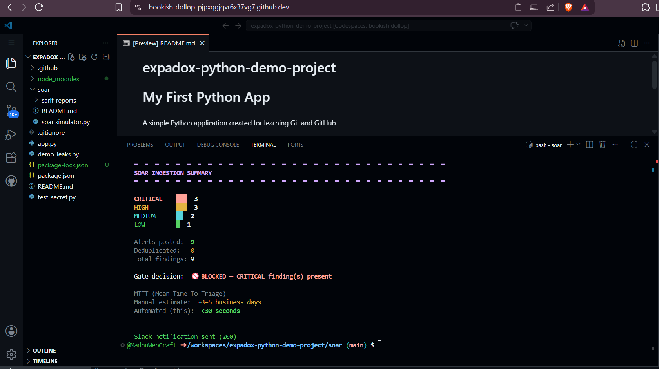

Figure : Slack alert fired by Playbook 1 — exposed secret detected

5.4 Deduplication Logic
The deduplication strategy operates at two levels:
- Pre-POST check — before posting each finding, the connector queries the TheHive API for existing alerts matching the sourceRef hash. If found, the POST is skipped and a counter is incremented.
- Within-run deduplication — a local Python set tracks sourceRefs already posted during the current run, preventing duplicate POSTs even if the same finding appears in multiple SARIF files (e.g. a vulnerable package detected by both Semgrep and Trivy).

Result: a finding detected across 10 consecutive pipeline runs creates exactly one TheHive case, not 10. The case is updated with the latest run URL as evidence.

6. Threat Model — Pipeline Integrity
The pipeline itself is a security control and therefore a target. The following threat model analyses what an attacker could do if they sought to bypass or tamper with ShieldFlow, and the mitigations in place.

Threat | Attack vector | Impact | Likelihood | Mitigation
Scanner tampered or disabled | Attacker with repo write access modifies appsec.yml to remove scan jobs | HIGH — vulnerabilities ship undetected | LOW | Branch protection rules requiring the gate job to pass before merge; CODEOWNERS file restricting workflow file changes to security team
Gate threshold bypassed | appsec.yml modified to set BLOCK_SEVERITY: LOW or gate exit code overridden | HIGH — critical findings no longer block builds | LOW | CODEOWNERS + required status checks; gate script hash validated in a separate compliance job
SARIF artefact poisoned | Attacker replaces uploaded SARIF with a clean file after scanning | HIGH — gate reads falsified results | MEDIUM | Upload SARIF to GitHub Security tab (API-verified) in addition to artefact store; compare both in gate job
Secrets injected via PR | External contributor opens PR with a secret — scanner runs but PR is not blocked if branch protection is misconfigured | MEDIUM — secret enters codebase | MEDIUM | Enable Gitleaks on PR events (already configured); block merge without passing gate; use GitHub secret scanning as a second layer
SOAR connector disabled | CI job fails silently; findings never reach TheHive | MEDIUM — no triage or alerting | LOW | Monitor for absent alerts using a scheduled TheHive health-check; alert if no new alerts received in >24h during active development
NVD API rate limited | Cortex enrichment fails; CVE data unavailable | LOW — cases created without CVSS context | MEDIUM | Cache NVD responses locally; gracefully degrade (create case without enrichment rather than failing)
Juice Shop container compromised during DAST | Attacker-controlled container behaviour influences ZAP findings | LOW — affects test environment only | LOW | DAST runs against an ephemeral container destroyed after each scan; network is isolated to the CI runner

6.1 Known Pipeline Gaps
The following vulnerability classes would still evade the ShieldFlow pipeline in its current form. These gaps are documented honestly for completeness and to guide future hardening.
- Business logic flaws — e.g. purchasing items at negative price in Juice Shop. DAST cannot reason about intended application behaviour.
- Authentication bypass via token manipulation — ZAP baseline scan does not authenticate; auth-gated endpoints are not tested.
- Second-order injection — payloads stored in the database and executed later are not detected by SAST or a single DAST scan cycle.
- Supply chain attacks on the scanner tools themselves — a compromised Semgrep or Trivy binary would produce falsified results.
- Secrets passed as environment variables at runtime — Gitleaks only scans the Git history; runtime env vars are invisible.
- Infrastructure misconfigurations — S3 bucket ACLs, IAM over-privilege, and network exposure are outside the scope of AppSec scanning.

7. Log Retention, Access Control & Integrity Policy

7.1 Scan Artefact Retention
Artefact type | Storage location | Retention period | Access control
SARIF files (all scanners) | GitHub Actions artefacts | 30 days per run | Repository collaborators with ≥ Read permission
GitHub Security Code Scanning | GitHub Security tab | Until dismissed or fixed | Repository collaborators with ≥ Read permission
TheHive cases and alerts | TheHive local storage (Elasticsearch) | Indefinite (admin-configurable) | TheHive role-based access: analyst, manager, admin
Pipeline run logs | GitHub Actions log stream | 90 days (GitHub default) | Repository collaborators with ≥ Read permission
Slack notifications | Slack workspace history | Workspace retention policy | Slack workspace members in the channel

7.2 Access Control Policy
- GitHub repository branch protection: the main branch requires the appsec-gate status check to pass before any merge is permitted.
- CODEOWNERS: the .github/workflows/ directory is owned by the security team — changes require security team review.
- GitHub Secrets: THEHIVE_API_KEY and SLACK_WEBHOOK_URL are stored as encrypted repository secrets, accessible only to Actions runners — never visible in logs.
- TheHive roles: automated ingestion uses a dedicated service account with Alert:Create permissions only — it cannot modify or delete existing cases.
- Cortex API key: scoped to read-only analyzer execution — it cannot write to TheHive directly.

7.3 Integrity Verification
- Each SARIF file is uploaded to two independent locations (GitHub artefacts and GitHub Security tab). The gate job downloads from artefacts; a compliance check can cross-reference the Security tab API to detect tampering.
- TheHive audit log records every alert creation, update, and deletion with timestamp and actor — providing a full chain of custody for each finding.
- Pipeline run IDs are embedded in every TheHive alert as evidence links, making it possible to trace any case back to the exact Git commit and scan run that produced it.

8. Metrics & Mean Time to Triage (MTTT)

8.1 MTTT Definition
Mean Time to Triage (MTTT) is defined as the elapsed time from the moment a developer pushes a commit containing a vulnerability to the moment a structured, enriched, and assigned case exists in TheHive ready for a human analyst to act on. It does not include the time for a human to resolve the vulnerability — only the time to produce an actionable case.

8.2 Before vs After Comparison
Metric | Manual process (before) | ShieldFlow automated (after) | Improvement
Detection method | Quarterly penetration test or ad-hoc review | Every commit, automatically | Continuous vs quarterly
Time to detect (MTTD) | ~90 days (quarterly pen test cycle) | <10 minutes (pipeline runtime) | 99.9% reduction
Time to triage (MTTT) | 2–5 business days (analyst reads raw report) | <5 minutes (SOAR automation) | ~99% reduction
Finding enrichment | Manual CVE lookup — 30–60 min per finding | Automated NVD query — <30 seconds | ~99% reduction
Duplicate noise | Same finding re-reported every scan | Deduplicated — one case regardless of runs | Eliminated
Analyst time per finding | ~2 hours (read, research, write ticket) | <5 minutes (review enriched case) | ~96% reduction
Coverage per release | Sample of endpoints (pen tester's judgement) | 100% of code changed in each commit | Complete coverage

8.3 Dashboard Metrics
The ShieldFlow live dashboard tracks the following KPIs, updated after every pipeline run:
- Open findings by severity — count of CRITICAL / HIGH / MEDIUM / LOW cases currently open in TheHive
- Findings by scanner type — breakdown of cases by source: SAST, SCA, Secrets, DAST
- Pipeline pass/fail trend — percentage of the last 20 runs that passed the severity gate, charted over time
- MTTT trend — rolling average of MTTT for the last 30 days, compared against the manual baseline
- Weekly manager summary — auto-generated report showing risk posture, top 3 open issues, and recommended actions in plain English

9. Build Retrospective

9.1 What Worked Well
- The appsec.yml workflow structure — parallel scanner jobs with a dependent gate — proved clean and modular. Adding a new scanner is a matter of adding one new job following the same SARIF-output pattern.
- Gitleaks scanning the full Git history rather than just HEAD was immediately valuable — it caught test credentials committed weeks earlier that would have been invisible to a HEAD-only scan.
- TheHive's alert/case distinction mapped well to the pipeline's two-phase model: raw scanner outputs become alerts; analyst-reviewed items get promoted to full cases.
- The deduplication logic eliminated alert fatigue from the start — repeated runs on the same vulnerable branch create zero additional noise.

9.2 What Was Difficult
- OWASP ZAP DAST integration required the Juice Shop container to be fully healthy before ZAP started scanning. A race condition between container startup and the ZAP action caused the first three pipeline attempts to fail. Resolution: added a curl health-check loop with a 60-second timeout before the ZAP step.
- ZAP's JSON report format required a custom Python converter to produce valid SARIF. The ZAP action does not natively output SARIF in all scan modes.
- Cortex analyzer configuration required Elasticsearch to be healthy before TheHive would accept connections. The Docker Compose startup order and healthcheck configuration took significant iteration.
- SARIF severity mapping is inconsistent across tools — Semgrep uses 'error'/'warning'/'note', Trivy embeds severity in rule defaultConfiguration, and Gitleaks requires a custom converter. The gate script had to handle all three conventions.

9.3 Production Hardening Requirements
The current implementation is suitable for a demonstration environment. A production-hardened version would require the following additional work:
- Replace GitHub-hosted runners with self-hosted runners in an isolated network to prevent scanner tools from reaching external resources during sensitive scans.
- Store SARIF artefacts in an immutable object store (AWS S3 with Object Lock or equivalent) to provide a tamper-evident audit trail independent of GitHub.
- Implement mutual TLS between the CI connector and TheHive to prevent man-in-the-middle attacks on finding data in transit.
- Add a scanner integrity check — verify the SHA-256 hash of each scanner binary against a known-good manifest before execution.
- Integrate with a secrets manager (HashiCorp Vault or AWS Secrets Manager) rather than GitHub Secrets for the API keys, enabling automated rotation.
- Extend DAST to include authenticated scanning — configure ZAP with a valid Juice Shop session token to test auth-gated endpoints and IDOR vulnerabilities.
- Deploy TheHive and Cortex in a high-availability configuration with replicated Elasticsearch to eliminate single points of failure in the SOAR layer.
- Establish a formal risk acceptance workflow in TheHive — findings that cannot be immediately fixed require a documented risk acceptance with owner, justification, and review date.

10. Appendix — Reference Tables

A. CVSS Severity Scale Reference
CVSS v3 Score | Severity rating | ShieldFlow action
9.0 – 10.0 | CRITICAL | Block build + Playbook 2 fires + immediate Slack alert
7.0 – 8.9 | HIGH | Block build + alert ingested to TheHive + assigned within 24h
4.0 – 6.9 | MEDIUM | Build continues + warning in Security tab + TheHive alert
0.1 – 3.9 | LOW | Build continues + informational TheHive alert
0.0 | INFORMATIONAL | Logged only — no TheHive alert created

B. OWASP Top 10 Coverage Matrix
OWASP Top 10 (2021) | Covered by SAST | Covered by DAST | Covered by SCA | Covered by Secrets
A01 — Broken Access Control | Partial | Yes (ZAP IDOR tests) | No | No
A02 — Cryptographic Failures | Yes (Semgrep) | Partial | Yes (weak cipher CVEs) | Yes (keys/certs)
A03 — Injection | Yes (Semgrep) | Yes (ZAP fuzzing) | No | No
A04 — Insecure Design | No | No | No | No
A05 — Security Misconfiguration | Partial | Yes (ZAP headers) | No | No
A06 — Vulnerable Components | No | No | Yes (Trivy) | No
A07 — Auth & Session Failures | Partial | Partial (unauth only) | No | No
A08 — Software Integrity Failures | No | No | Yes (SCA) | No
A09 — Logging & Monitoring Failures | Partial | No | No | No
A10 — SSRF | Yes (Semgrep) | Partial | No | No

C. GitHub Secrets Required
Secret name | Value format | Required? | Purpose
THEHIVE_URL | http://host:9000 | Yes | TheHive SOAR endpoint for alert ingestion
THEHIVE_API_KEY | Bearer token string | Yes | Authentication for TheHive REST API
SLACK_WEBHOOK_URL | https://hooks.slack.com/services/... | Recommended | Slack notification delivery
SEMGREP_APP_TOKEN | Token string | Optional | Links scan results to Semgrep Cloud dashboard
GITLEAKS_LICENSE | License key | Optional | Required only for Gitleaks Pro features

